
Land Information Ontario (LIO) Warehouse
Data Class Name: UTM 100KM Grid
Documentation
Produced by: Information Access and Information Management Policy Unit
Ministry of Natural Resources and Forestry
Date: July 27, 2015

Purpose

This document provides additional information to support the use of geospatial data. The Physical Model Diagram provides a visual representation of the relationships in the data class. The Data Change History lists all the modelling and access changes that have occurred during the lifecycle of the data class. A data description identifying table and field names is available upon request.

Need Assistance?
Please contact LIO Support at lio@ontario.ca or 705-755-1878 if you require help.

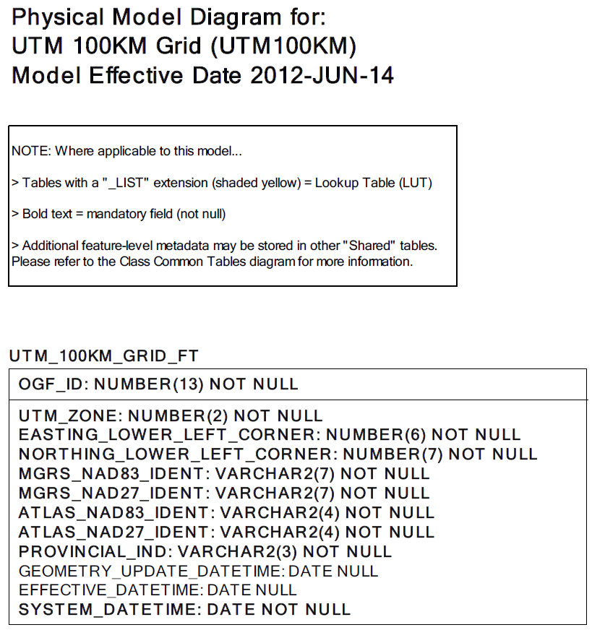

Data Class Change History

Data Class Name: UTM 100KM Grid
Data Class Short Name: UTM100KM
Date  YYYY-MM-DD | Details of Change
2011 | NEW Data Class created to provide a standard 100km x 100km reference index for general use which would include the most commonly used business area identifiers, minimizing the creation of future adhoc products.
Data Description
Please refer to the metadata record for the data description.

